Array & Aggregation Operations
Ques1. Display all employees who have MongoDB skill.
Query :- db.employees.find({skill:"MongoDB"})
Output:-
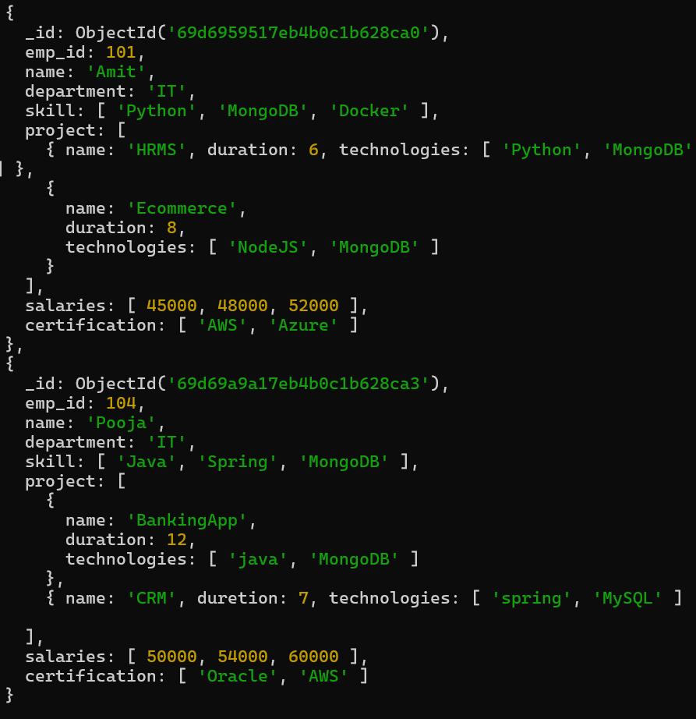
Ques2. Find employees having both Python and MongoDB skills.
Query :- db.employees.find({skill:{$all:["Python","MongoDB"]}})
Output:-
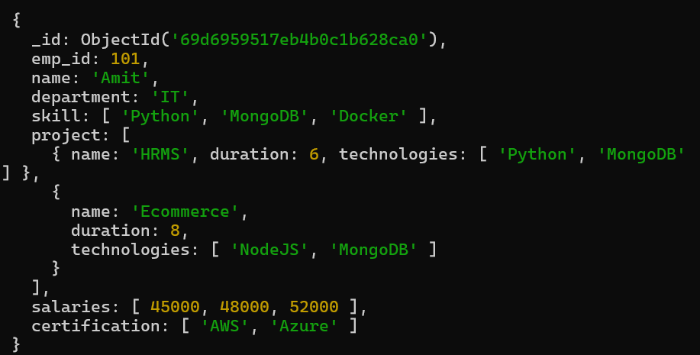
Ques3. Display employees with more than 2 skills.
Query :- db.employees.find({$expr:{$gt:[{$size:"$skill"},2]}})
Output:-
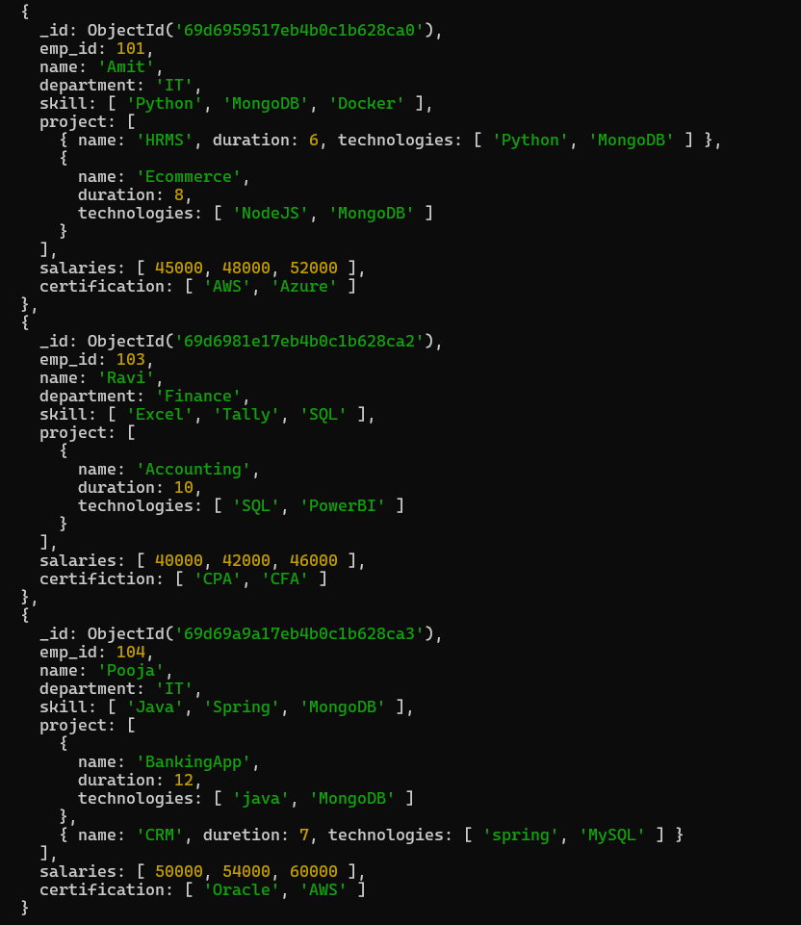
Ques4. Add a new skill "Kubernetes" to Amit.
Query :- db.employees.updateOne({name:"Amit"},{$addToSet:{skill:"Kubernetes"}})
Output:-
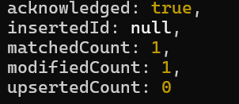
Query :- db.employees.find()
Output:-

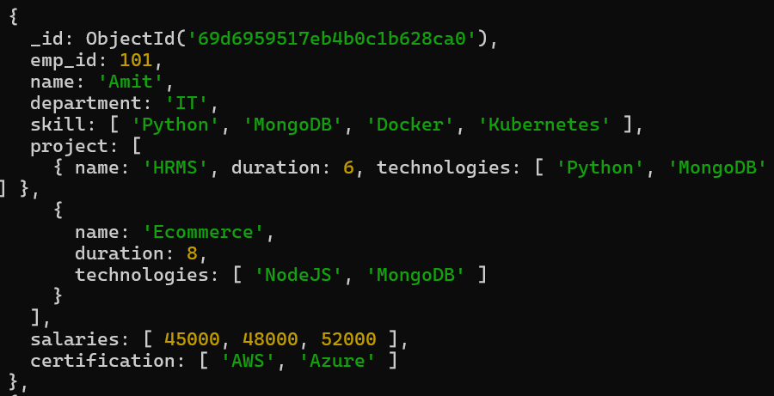
Ques5. Add multiple skills to Pooja.
Query :- db.employees.updateOne({name:"Pooja"},{$addToSet:{skill:{$each:["Python","Data Analysis"]}}})
Output:-
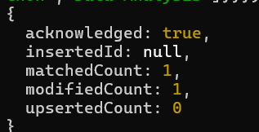
Query :- db.employees.find()
Output:-
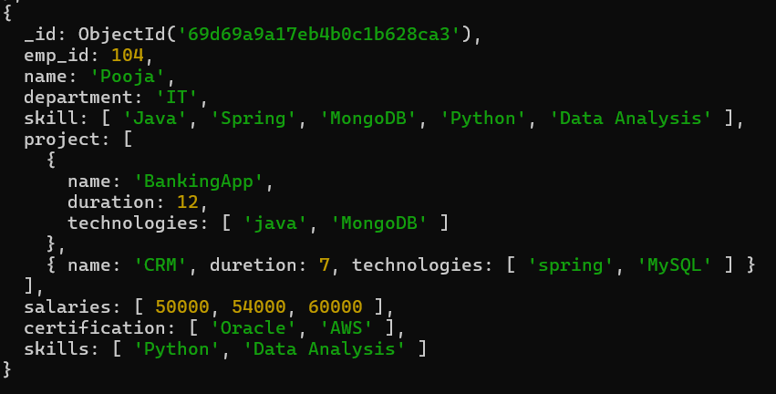
Ques6. Add a certification only if not already present.
Query :- db.employees.updateOne({name:"Pooja"},{$addToSet:{certification:"AWS Certified Developer"}})
Output:-
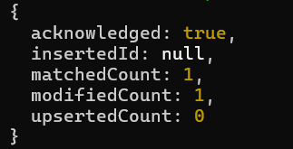
Query :- db.employees.find()
Output:-
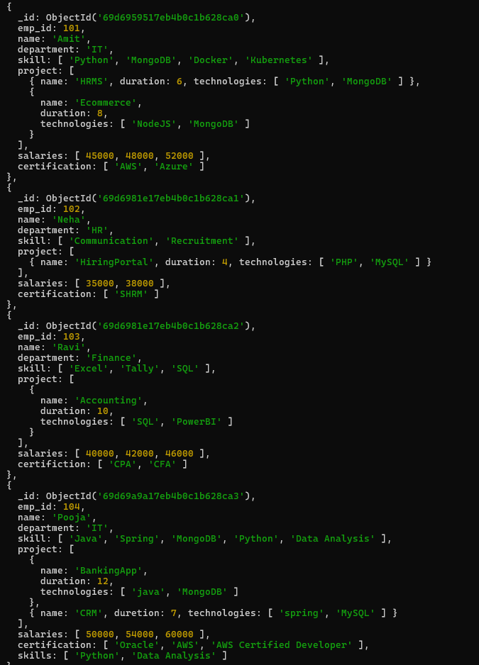
Ques7. Remove "Docker" skill from Amit.
Query :- db.employees.updateOne({name:"Amit"},{$pull:{skill:"Docker"}})
Output:-
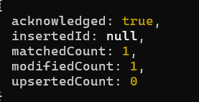
Query :- db.employees.find()
Output:-
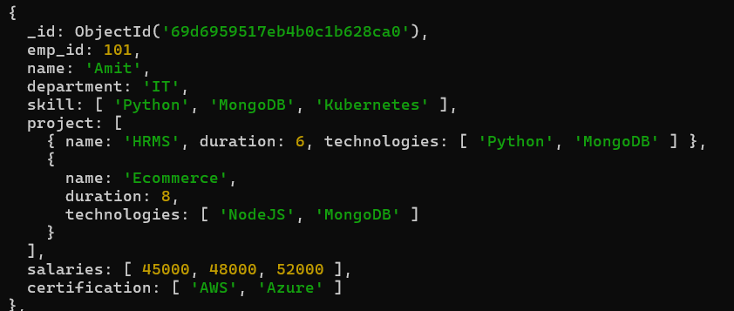
Ques8. Remove multiple salaries less than 45000.
Query :- db.employees.updateMany( {},{$pull:{salaries:{$lt:45000}}})
Output:-
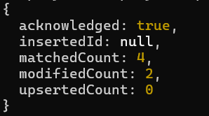
Query :- db.employees.find()
Output:-
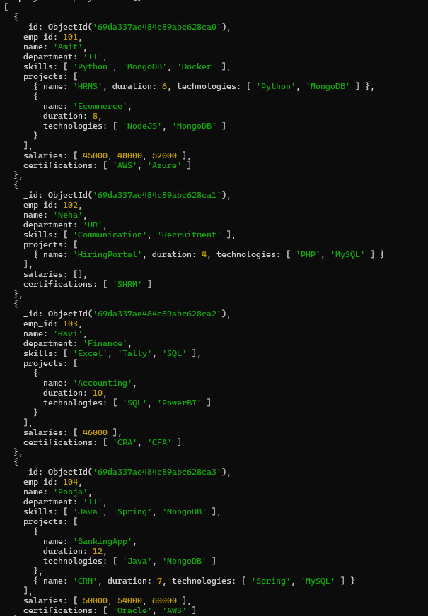
Ques9. Find employees who worked on MongoDB projects.
Query :- db.employees.find({"projects.technologies":"MongoDB"})
Output:-

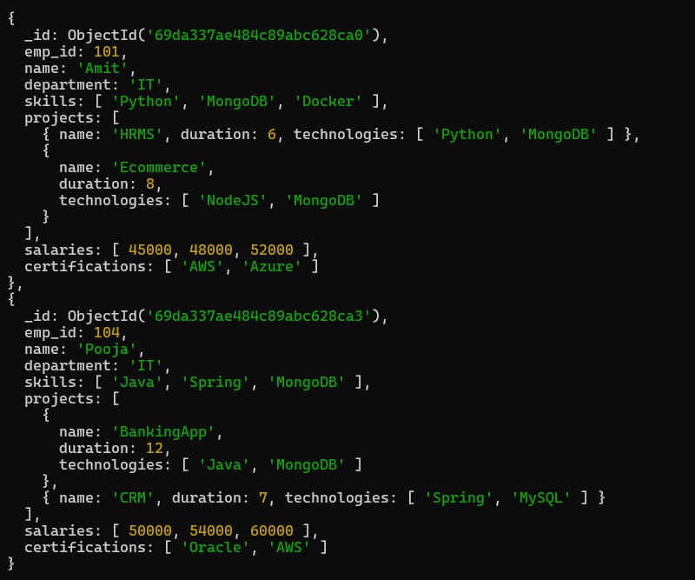
Ques10. Use $elemMatch to find project duration > 6 using MongoDB.
Query :- db.employees.find({projects:{$elemMatch:{duration:{$gt:6}}}})
Output:-
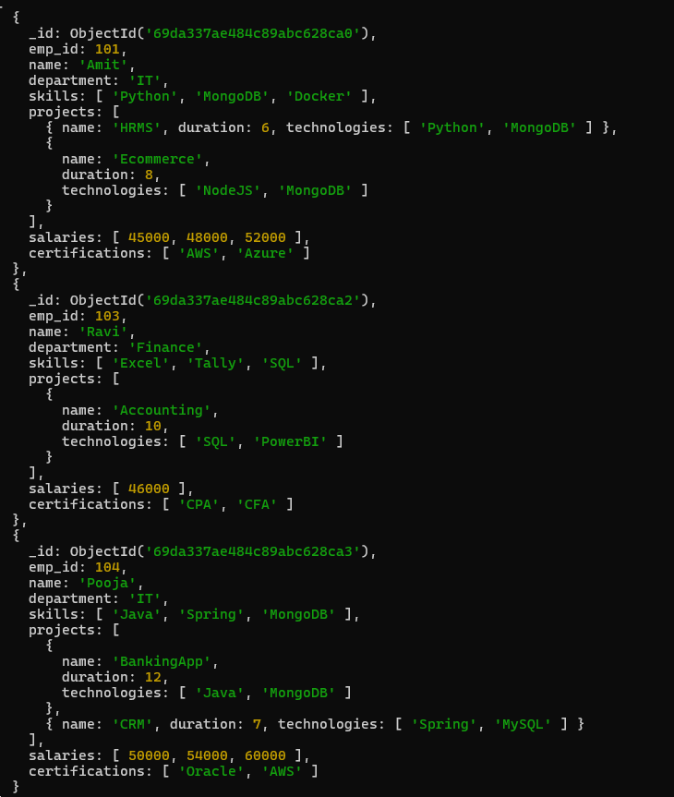
Ques11. Count number of projects for each employee.
Query :- db.employees.aggregate([{$project:{name:1,projectCount:{$size:"$projects"}}}])
Output:-
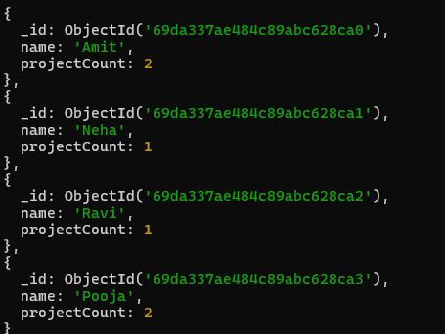
Ques12. Unwind skills array.
Query :- db.employees.aggregate([{$unwind:"$skills"}])
Output:-
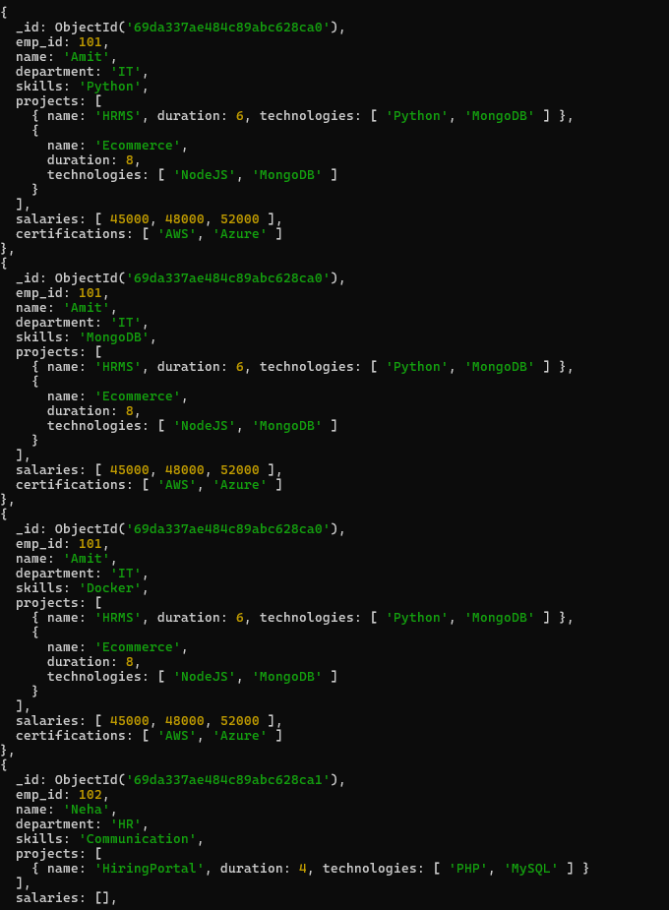
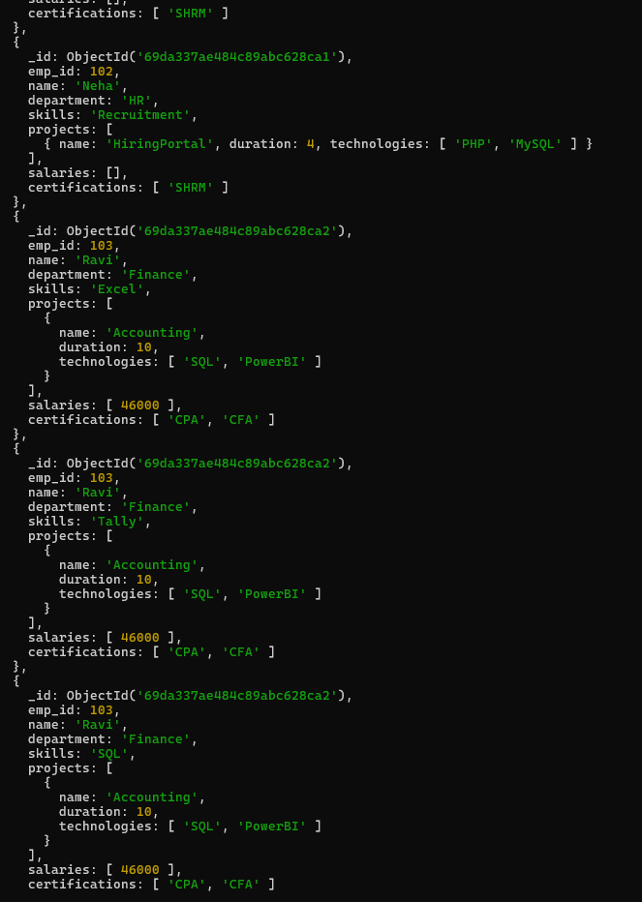
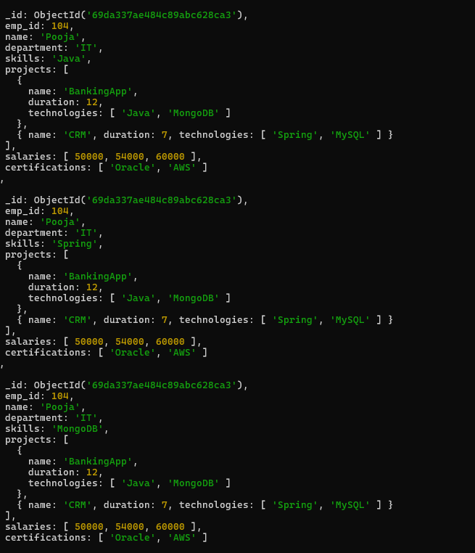
Ques13. List unique skills across company.
Query :- db.employees.distinct("skills")
Output:-
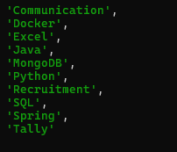
Ques14. Find employees with salary greater than 50000
Query :- db.employees.find({salaries:{$gt:50000}})
Output:-
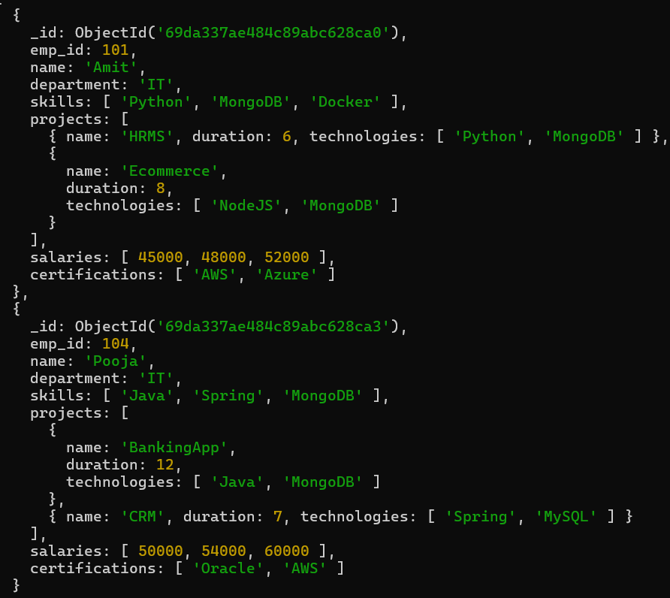
Ques15. Find employees with exactly 2 certifications.
Query :- db.employees.find({certifications:{$size:2}})
Output:-
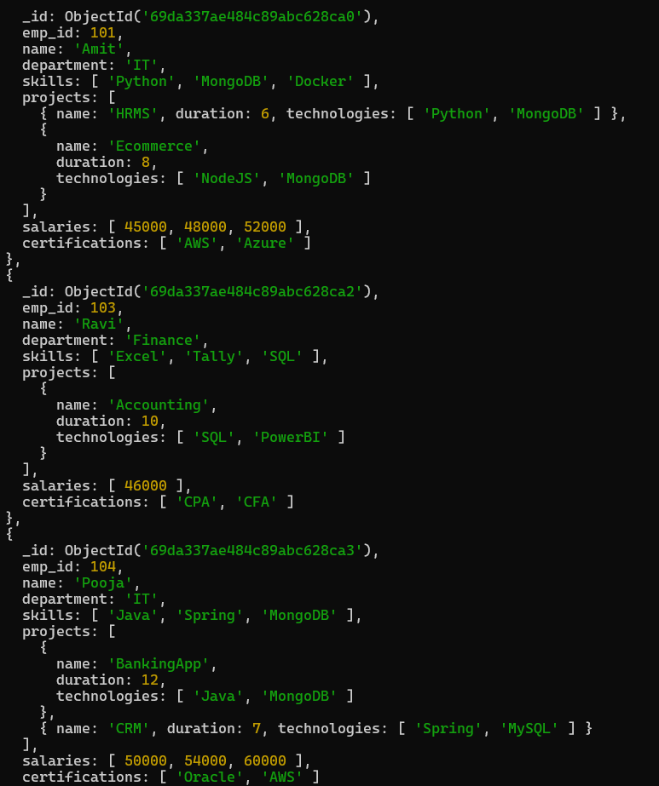
Ques16. Add new project to Ravi.
Query :- db.employees.updateOne({name:"Ravi"},{$push:{projects:{name:"DataWarehouse",duration:8,technologies:["MongoDB","Python"]}}})
Output:-
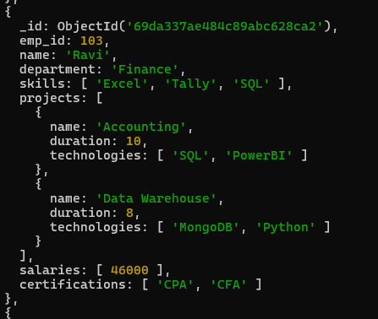
Ques17. Increase all salaries by 10% (array update).
Query :- db.employees.updateMany({},{$mul:{"salaries.$[]":1.10}})
Output:-
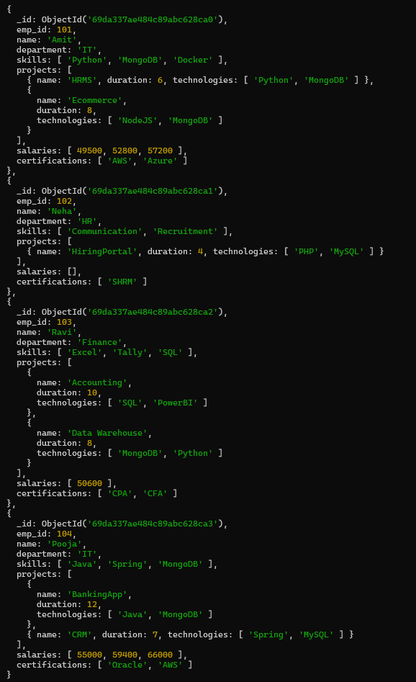
Ques18. Find highest salary of each employee.
Query :- db.employees.aggregate([{$project:{_id:0,emp_id:1,name:1,highestSalary: {$max:
"$salaries"}}}])
Output:-
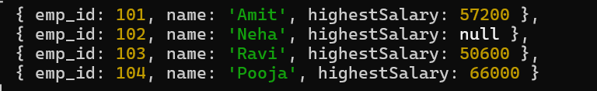
Ques19. Find average salary of employees.
Query :- db.employees.aggregate([{$project:{_id:0,emp_id:1,name:1,avg_Salary:{$avg:"$salaries"}}}])
Output:-
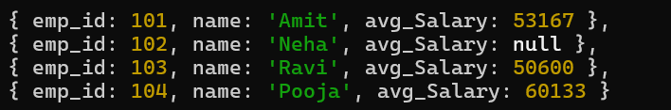
Ques20. Filter projects longer than 6 months.
Query :- db.employees.aggregate([{$project:{_id:0,name:1,filtereProjects:{$filter:{input: "$projects",as:"proj",cond:{$gt:["$$proj.duration",6]}}}}}])
Output:-
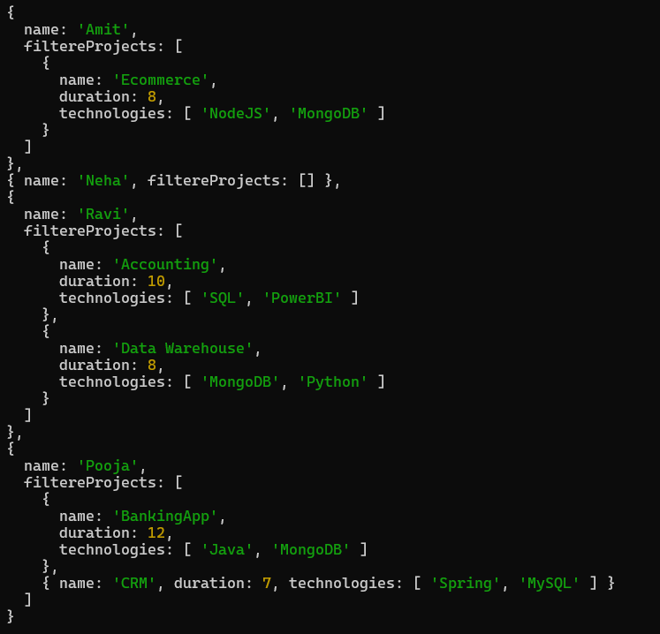
Ques21. Find employees who have any of these skills: Java or Python.
Query :- db.employees.find({skills:{$in:["Java","Python"]}})
Output:-
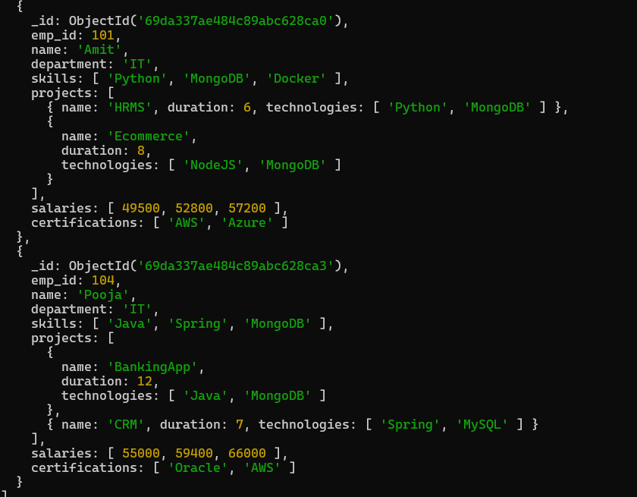
Ques22. Remove last salary entry.
Query :- db.employees.updateMany({},{$pop:{salaries:1}})
Output:-
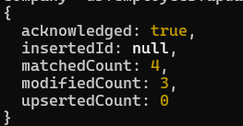
Query :- db.employees.find()
Output:-
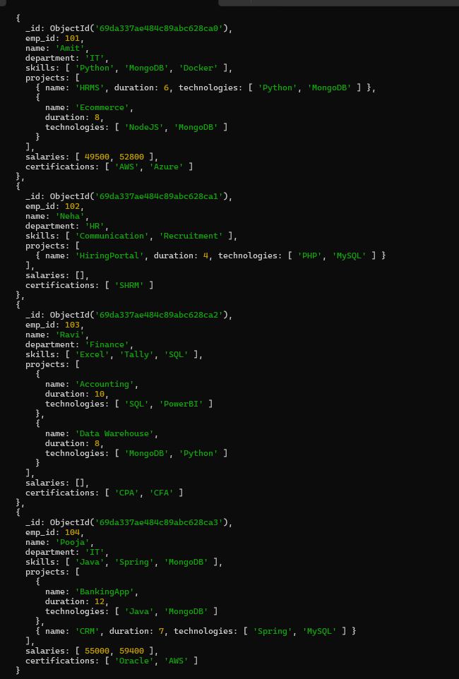
Ques23. Remove first salary entry.
Query :- db.employees.updateMany({},{$pop:{salaries:-1}})
Output:-
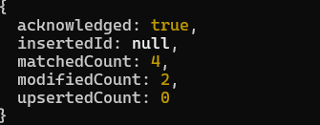
Query :- db.employees.find()
Output:-
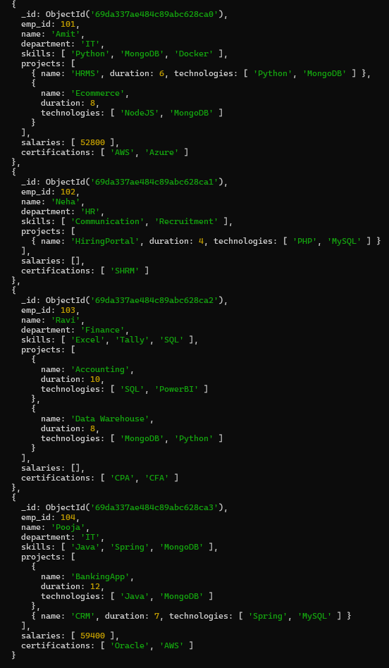
Ques24. Sort salaries array.
Query :- db.employees.updateMany({},{$push:{salaries:{$each:[],$sort:1}}})
Output:-
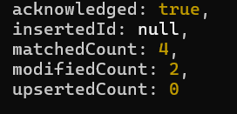
Query :- db.employees.find()
Output:-
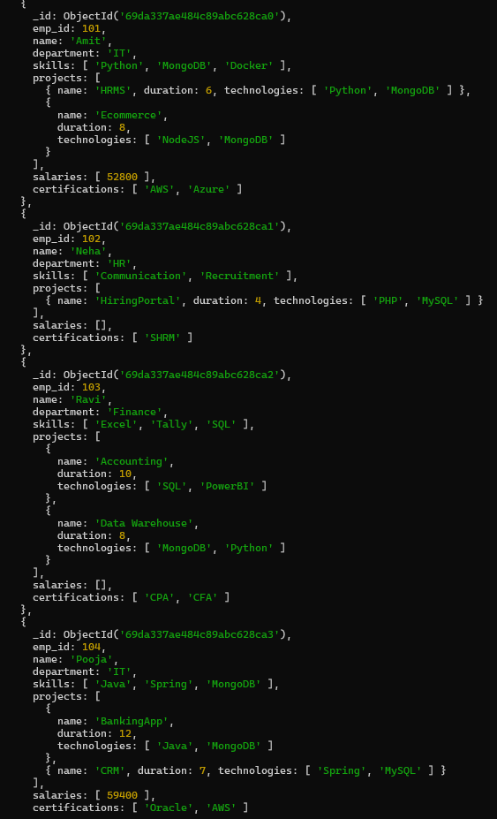
Ques25. Limit salaries array to last 2 entries.
Query :- db.employees.updateMany({},{$push:{salaries:{$each:[],$slice:-2}}})
Output:-
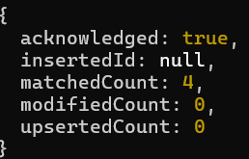
Query :- db.employees.find()
Output:-
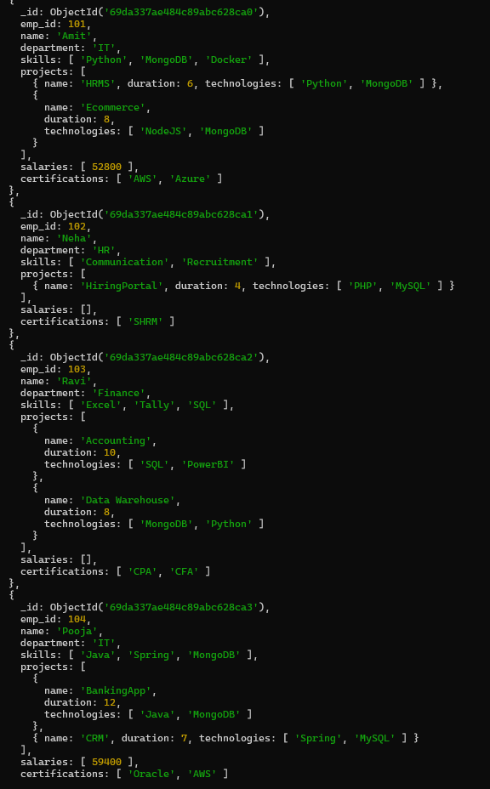
Ques26. Find total salary paid to each employee.
Query :- db.employees.aggregate([{$project:{_id:0,emp_id:1,name:1,total_salary_paid:{$sum:
"$salaries"}}}])
Output:-
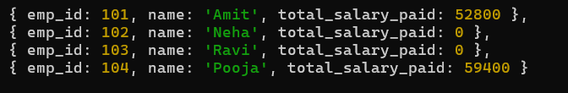
Ques27. Convert skills to uppercase.
Query :- db.employees.updateMany({},{$push:{skills:{$each:[],$sort:1}}})
Output:-
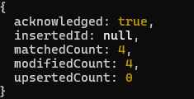
Query :- db.employees.find()
Output:-
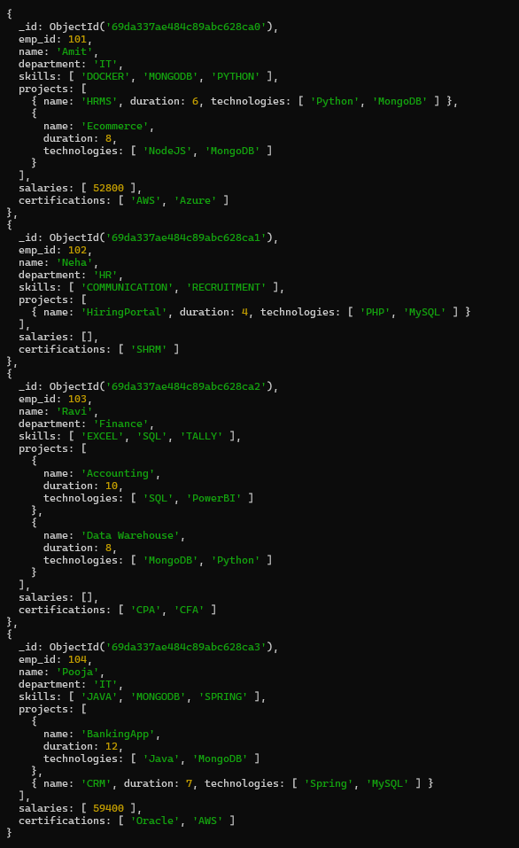
Ques28. Find employees with more than one project.
Query :- db.employees.find({"projects.1":{$exists:true}})
Output:-
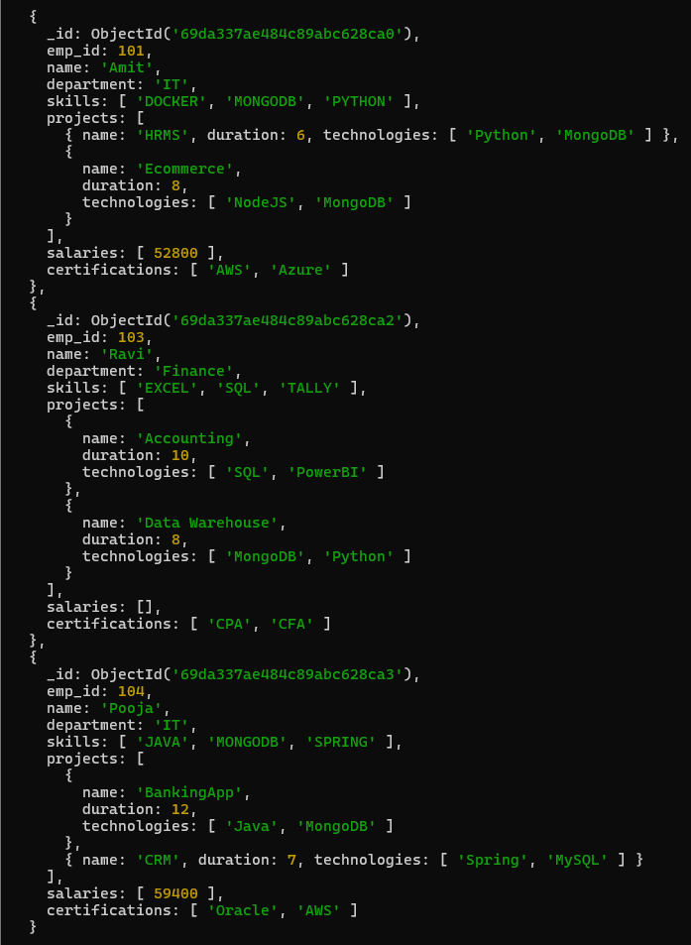
Ques29. Count employees per skill.
Query :- db.employees.aggregate([{$unwind:"$skills"},{$group:{_id:"$skills",employee_count:
{$sum:1}}}])
Output:-
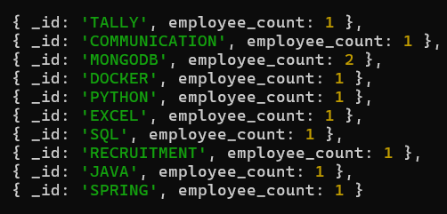
Ques30. Find employees whose all projects use MongoDB.
Query :- db.employees.find({"projects.0":{$exists:true},projects:{$not:{$elemMatch:{technologies:
$ne:"MongoDB"}}}}})
Output:-
